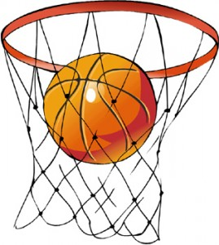

Basketball PICTURE/WORD Game

Objective: (Group class into teams and they will compete to win a prize.)
Students will give the correct word that goes with the picture given by teacher.
Response:
Students will receive a chance to shoot the “paper ball” to earn points for their team.
Prize:
The winning team will get to choose either a piece of candy or a sticker for their token board.

Vocabulary List: Topic: Animals
Butterfly Fish
Cow Fox
Dog Sheep
Elephant Owl
Panda Pig
Tiger Teddy Bear

