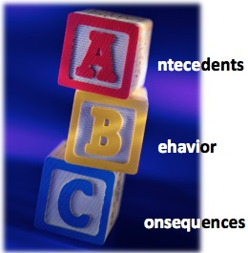
ABC Data Sheet
Antecedent | Behavior | Consequence | Possible Function
 |  |  | (Attention, Access to items/ activities, Escape, Sensory)
Record each instance of one behavior, as well as the antecedent (what happened right before the behavior), the consequence (what happened right after the behavior), and what the possible function of that behavior was (what outcome did it achieve for the child/student?).
Student Name: ___________________ Date: _________ Time of Observation: __________

